Volunteering Impact Measurement Training in Europe
V-CALC
Newsletter nº1:

Not just counting but understanding difference
A Theory of Change

Although engagement in volunteering activities is quite well known, and 100 million people in Europe volunteer, little is known about the breath-taking impacts achieved. There is also a lack of information about the profiles and motivation of these volunteers. Overall, there are no tools to measure it in a systematic form, information is poor and scattered, and volunteering is not regularly and/ comparatively tracked in official statistics.
Therefore, the V-CALC project is a great opportunity to lay the foundations for capacity building and tracking of volunteering’s impact. 800 volunteer managers and coordinators of all ages and diversity will be enabled to measure and understand the impact of their volunteers.
Partners involved in V-CALC (CEV, UEA, DKolektiv, OTB, Fundación Hazloposible and Beyond Barriers) represent a broad geographical distribution including EU and non-EU countries: Belgium, UK, Croatia, Spain and Albania. The chosen design will bring tailored expertise and experience to the needs of the project. Regarding the tasks allocated to deliver and successfully follow-up the project, we can observe the development of a user-friendly online platform along with an impact measurement methodology (the “Theory of Change” approach, later explained) and training activities to build capacity.
All of this, coupled with policy development work, will ensure the emergence of a community of practitioners from across Europe with knowledge to promote the use of the V-Calculator, and about the importance of measuring volunteering for the development of better evidence-based policies. Consequently, the effective implementation of the V-CALC project will lead to improvements and new approaches in a vast variety of volunteering contexts.

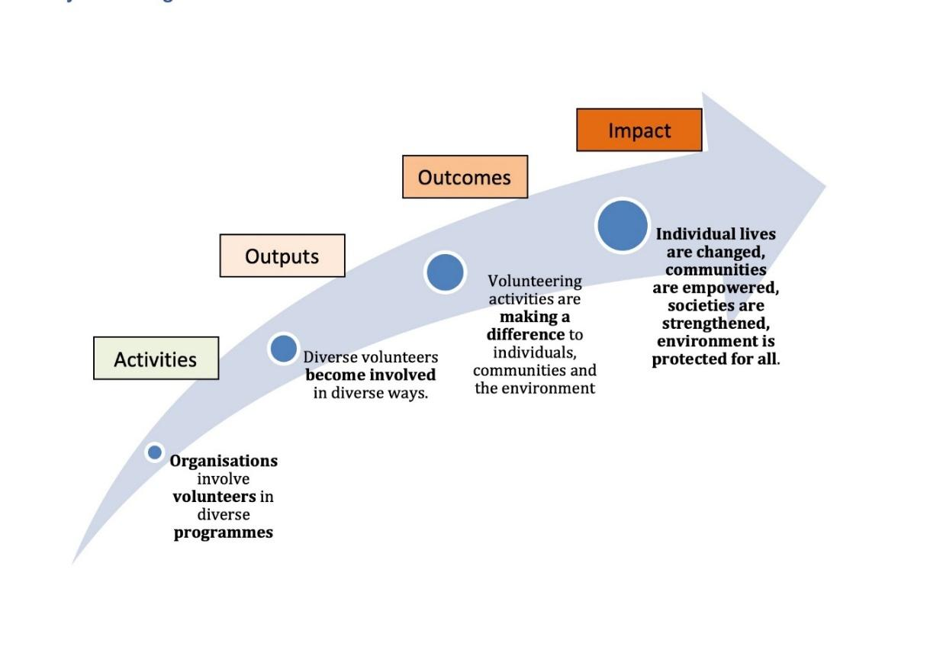
This bespoke ‘Theory of Change’ graphic for the project ‘Volunteering Impact Measurement Training in Europe (V-CALC)’ provides a basis for building a shared understanding of how volunteer involvement makes a difference.
It is difficult to assess the difference volunteer involvement makes, even if undertaken within a single cultural context and using just one language. It becomes more challenging, and requires highly inclusive and collaborative approaches, if it is to be undertaken, not just within, but also across cultural contexts and involving different European languages.
V-CALC is a complex project involving partners from five European nations co-designing and co-delivering a demanding programme of work, enabling volunteer managers and co-ordinators to measure and understand the impact of the volunteers they involve. The assessments will be designed so that they not only inform single nations, but that the data can be reported across them, offering a European picture. The first task for the V-CALC team was therefore to rapidly gain a shared understanding of the tasks and challenges ahead.
To achieve this, a ‘Theory of Change’ development approach was employed. The practical development of the ‘Theory of Change’ in meetings and consultations exemplifies that the entire project is underpinned by a commitment to collaboration and co-production. The above graphical representation of the Theory of Change was jointly developed as a roadmap for the V-CALC platform, materials and training, and will be used to inform the upcoming development of tools, to regularly review implementation and to guide the overall evaluation of the project. Further information about the ‘Theory of Change’ will be published in the broader V-CALC methodology at the end of the year.

To wrap up, the Erasmus+ Project V-CALC displays determination to overcome the challenges surrounding volunteering measurement, and excitement to build capacity for improvements. It will enable evidence-based understanding of the impact of volunteering in a wide variety of different contexts, largely thanks to the “Theory of Change” methodological approach which plays a crucial role as impact measurement methodology.


Centre European Volunteering
Institute for Volunteering Research - Groups and Centres (uea.ac.uk)
Dkolektiv
Out of The Box International
Fundación Hazloposible
Beyond Barriers

Funded by the European Union. Views and opinions expressed are however those of the author(s) only and do not necessarily reflect those of the European Union or EACEA. Neither the European Union nor the granting authority can be held responsible for them.

